Ex. No. : 01 Name: Shreya Amudhu.N.R
Register No. : 2116240701505
Dashboard

Aim
To create a simple Dashboard in Zoho Creator for the Library Management System without using Zia, by displaying useful reports and summary information from the existing application data.
Procedure
- Open the Zoho Creator application containing the Library Management System.
- Open the application in Edit mode.
- Go to the Pages section and create a new page for the dashboard.
- Give the page a suitable name such as Library Dashboard.
- Add the existing reports to the dashboard using Report widgets.
- Add the Loan Record Report to display borrowing and return information.
- Add the Library Items Report to display library item details.
- Add the Borrower Report to display registered borrower information.
- Add the Library Events Report to display upcoming or recorded library events.
- Arrange the reports neatly on the dashboard so that the important information can be viewed in one place.
- Save the dashboard and open it in Live mode to verify that all the reports are displayed correctly.

Screen shots:
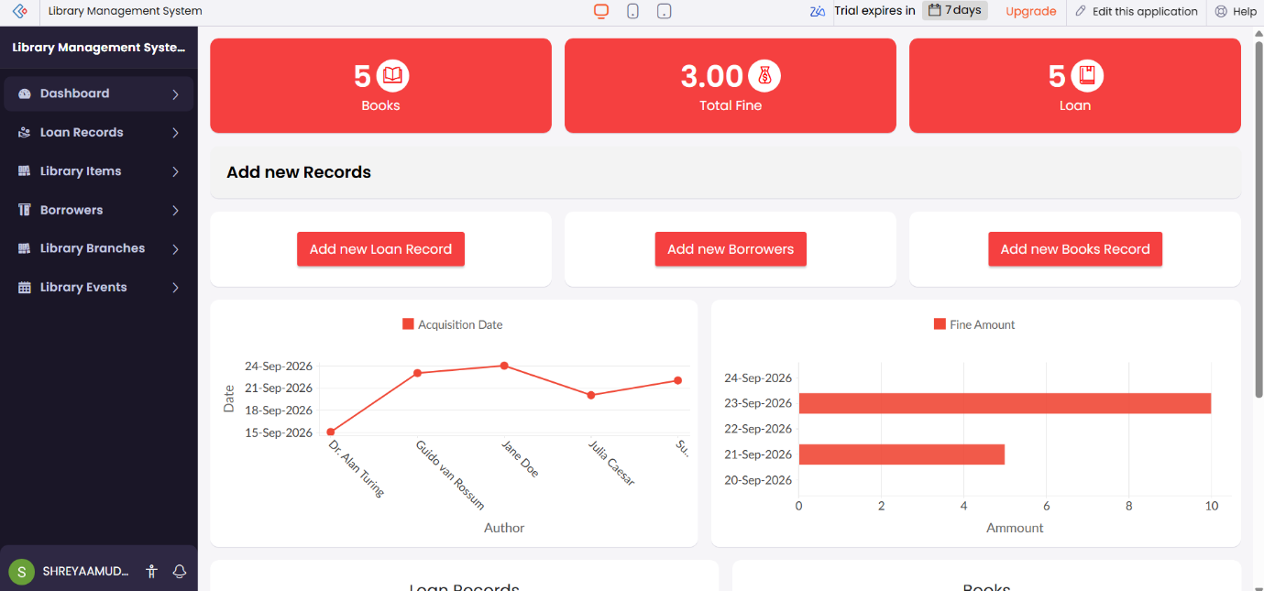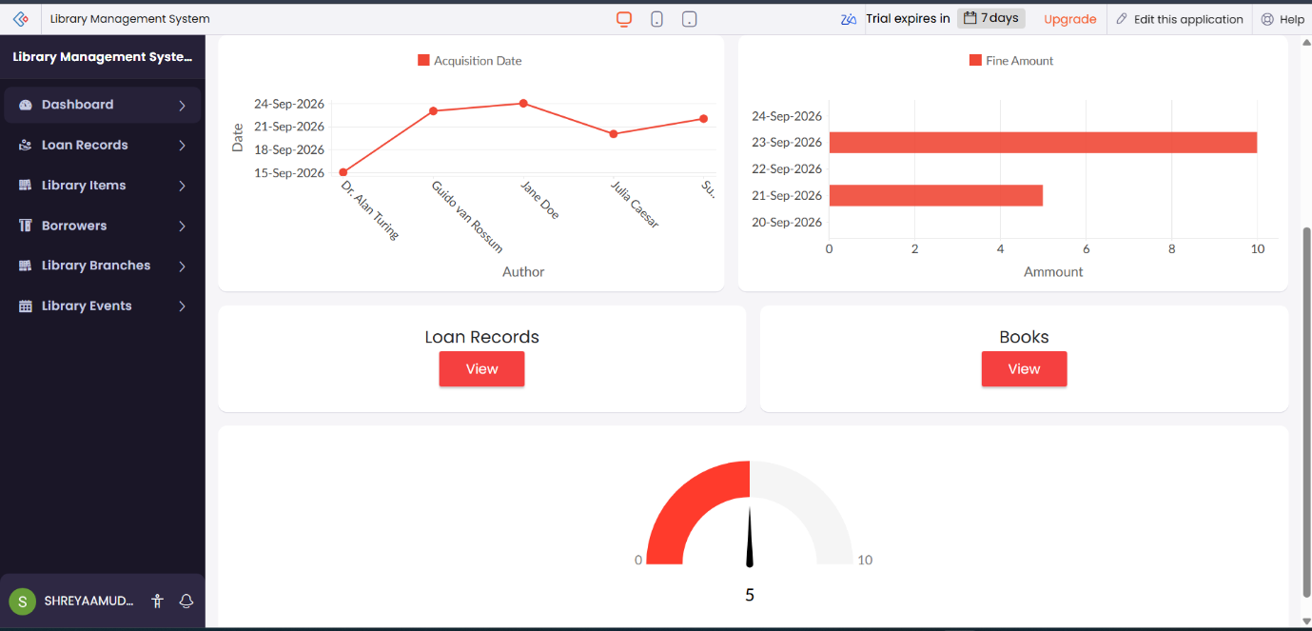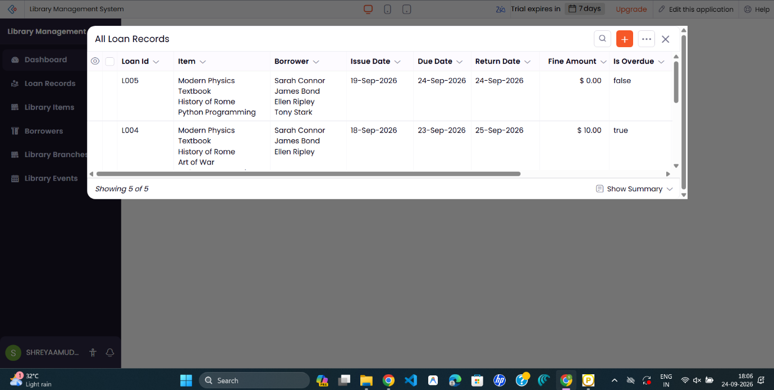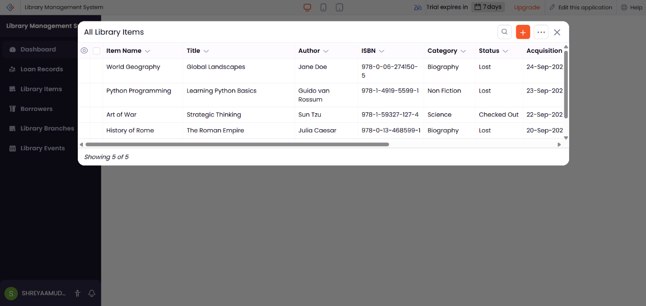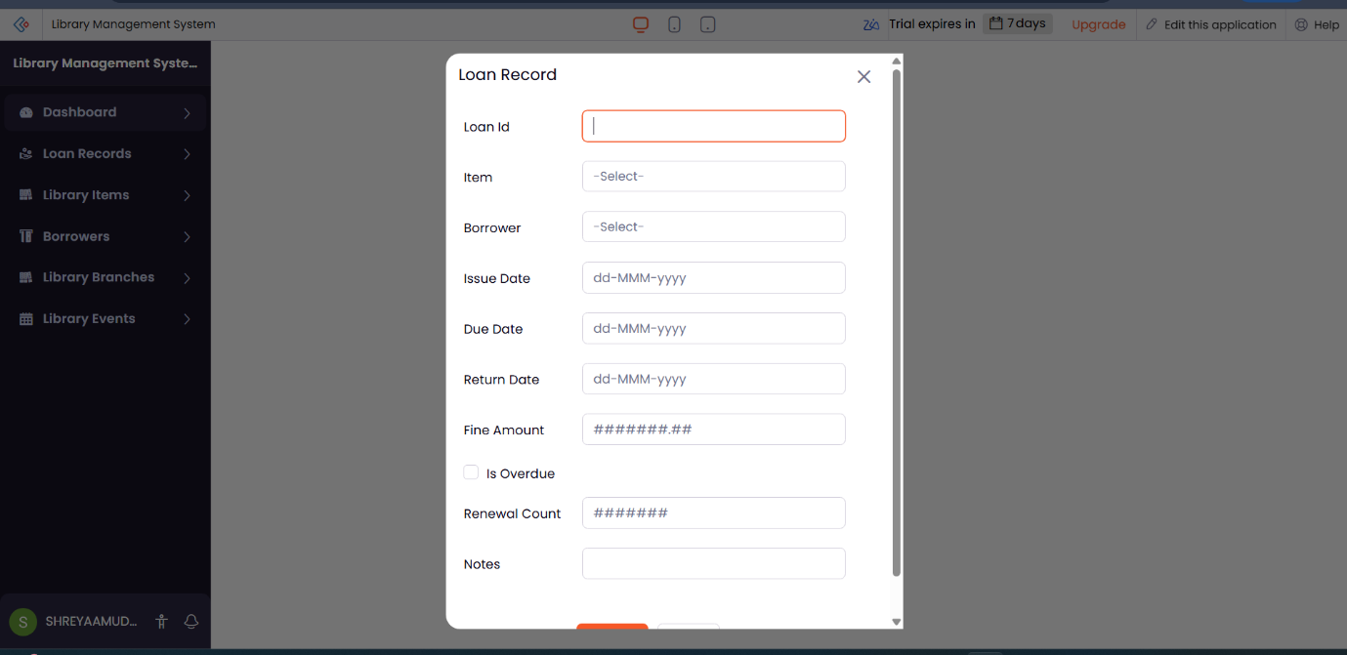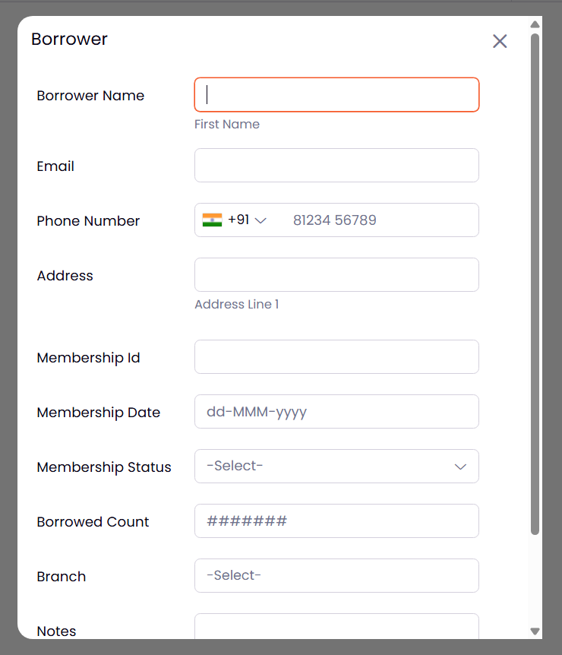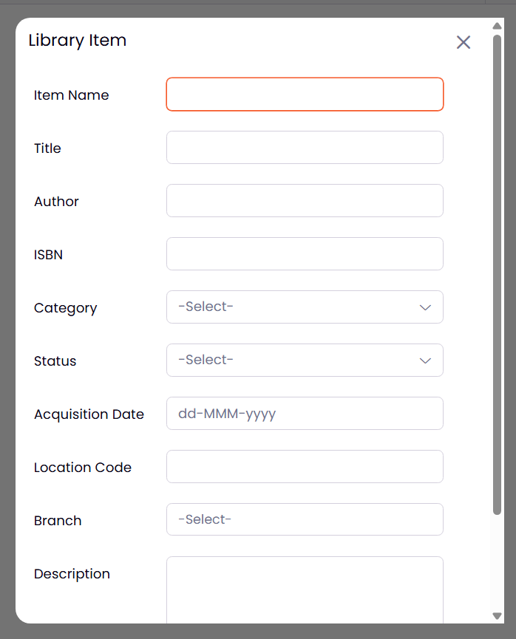

Result
Thus, a simple Library Management Dashboard was successfully created in Zoho Creator without using Zia. The dashboard combines the existing reports and provides an organized view of loan records, library items, borrowers, and library events in a single page.

